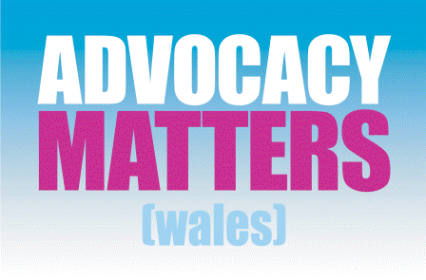

Independent Professional Advocacy (IPA)
AMW Referral Form

Ref No: for AMW admin

Please be aware, this service works with people who are:
18 years or older, have a Learning Disability and/or Autism
and live in Cardiff or the Vale (or whose local authority is Cardiff or the Vale)

This is a free service, and anyone can make a referral.

-----------------------------------
🗓 Date of Referral:
Please write the date here:

-----------------------------------

👤 Service User Details
Name:
Date of Birth:
Gender: Male/Female/Trans/Non-binary/ other (please state)
Address:
Email:
Contact Number:

-----------------------------------
👤 Referrer Details

If this is a Self-referral, please skip this section.
Name:
Role/Position/Relationship:
Organisation (if appropriate):
Email:
Phone:
Does the service user consent to be referred? Yes/No
If no, please explain:

---------------------------------------------------

✍️. Reason for Referral
Please provide details of why advocacy is needed:

-----------------------------------

🤝Supporting Professionals / Agencies Involved
If possible, please record details of any relevant professionals involved:

---------------------------------------------------

ℹ️ Additional Information
Please record any Diagnoses or Conditions:

Please record anything else you think the advocate should know to support you/ the service user effectively:

---------------------------------------------------
Please send to info@advocacymatterswales.co.uk

Advocacy Matters (Wales) is a registered charity 1055211
www.advocacymatterswales.co.uk

